**CITY COLLEGE OF COMMERCE & BUSINESS ADMINISTRATION (Under Graduate Institute)**

**Affiliated to University of Calcutta**

**Accredited by NAAC**

**13, SURYA SEN STREET KOLKATA-700012**

**NOTICE INVITING TENDER**

Date: 25/09/2025

**Issued by:**

City College of Commerce & Business Administration

(Under Graduate Institute)

Affiliated to University of Calcutta

Accredited by NAAC

13, SURYA SEN STREET KOLKATA-700012

Phone: 033-2219 6281

**Tender for appointment of Architect / Civil Engineering Firm for renovation & refurbishment of the Principal’s Room.**

City College of Commerce & Business Administration invites quotations from vendors for appointment of Architect / Civil Engineering Firm for renovation& refurbishment of the Principal’s Room with detailed specifications mentioned below:

|  |  |
| --- | --- |
|  |  |

**Detailed scope of services:**

* Preparation of drawings, designs, estimates.
* Preparation and uploading of NIT, BOQ and completion of entire process of e-Tender.
* Technical guidance and supervision for the execution of the works.
* Assistance in tendering and contractor selection.
* Certification of bills and quality monitoring.

**Eligibility Criteria:**

Vendors must have self-attested scan copies of:

* Architect/ Civil Engineering Firmwith Registration and Certification.
* PAN Card
* Trade License (current year)
* IT Return for the Last 2 Assessment Years

|  |  |
| --- | --- |
|  |  |

**Terms & Conditions:**

* Consultancy services must be started within 7 days from the date of issuance of work order.
* Payment Terms: An initial amount (negotiable) as advance shall be payable at the time of appointment and that amount would be adjusted against the total consultancy charges. Payment to be released in each stages as per progress of the work (negotiable).
* The Authorities reserve the right to accept or reject any/all quotations without assigning any reason.
* After evaluating the quotations the supply order to successful vendor will be issued thereafter by hand.

**Submission of Quotation:**

Last date of submission: 1st October, 2025.

Place of submission: Mail id.: [**tender@cccba.ac.in**](mailto:tender@cccba.ac.in) **[Since the college is closed due to Puja Vacation so, online submission will be valid only.]**

**Important dates:**

|  |  |
| --- | --- |
| Particulars | Date & Time |
| Tender Publish Date | 25/09/2025 after 5:00pm |
| Quotation submission starting date | 25/09/2025 after 5:00pm |
| Quotation submission closing date | 01/10/2025 upto 5:00pm |
| Quotation opening date[Online platform] | 03/10/2025 after 7:00pm |

For further clarifications, contact:

Dr. Barun Kumar Das

Convener, Tender Committee

City College of Commerce & Business Administration,

13, SURYA SEN STREET KOLKATA-700012. Issued by,

Phone: 033-2219 6281

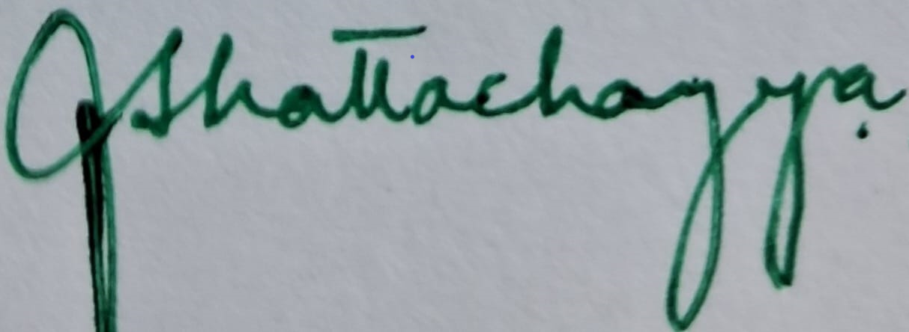

Principal

City College of Commerce & Business Administration